**Use Case Diagram:**

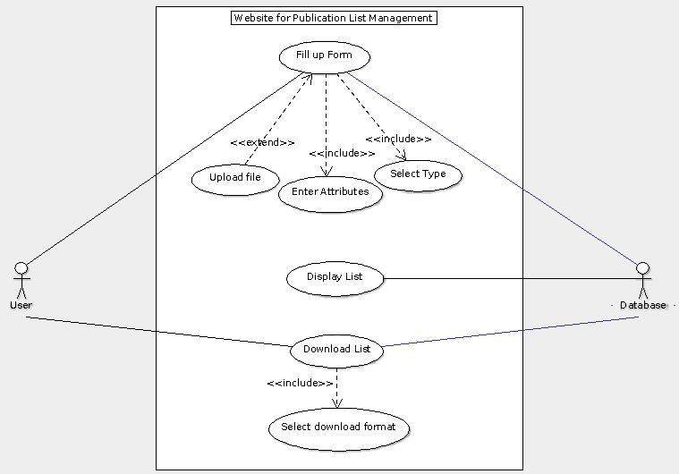

Fig: Use Case Diagram of Publication List Management

Use Cases of the above use case diagram are described below.

**Fill up form Use Case**

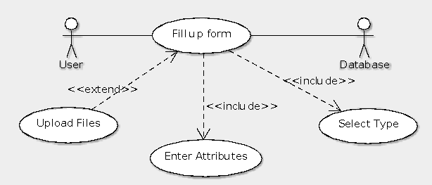

Fig: Fill up form Use Case

|  |  |
| --- | --- |
| Actors | User, Database |
| Includes | Enter Attributes, selection of type of publication |
| Extends | Upload files |
| Description | To store the published materials user fills up the form. First user select types of Publication (Journals, Research Articles, Books) and according to which the required form fields are generated. User fills up the fields as per the publication.Also, we provide a space to upload the published document so that it can be easily accessed in future.All those data are stored in database with safety and security. |
| Data | Publication type, Publication Details, Published Document. |
| Stimulus | When user clicks “Add Publication” button |
| Response | Confirmation that the publication database has been updated |

**Display List Use Case**

Fig: Display List Use Case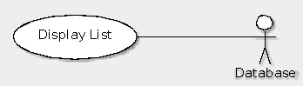

|  |  |
| --- | --- |
| Actors | Database |
| Description | Enable user to view the list of their publications with the list being categorized into types, sorted chronologically/lexicographically and searchable by keys. |
| Data | Data of published materials |
| Stimulus | Whenever User visits the website. |
| Response | List of published materials. |
| Comment | User can select the favourable way to display the list. |

**Download List use Case**

Fig: Download List Use Case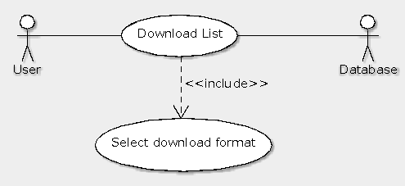

|  |  |
| --- | --- |
| Actors | User, Database |
| Includes | Selection of Download format |
| Description | User can select the appropriate standard(UGC, IEEE) to generate the list of published documents and user can download the formatted output in the form of docx, PDF or HTML. Also, user can select the type of file they want to download. |
| Data | Data of published documents(from database), Standards Selection Data(from User), Format of download(from User) |
| Stimulus | When user clicks “Format Publication” button. |
| Response | Docx, PDF or HTML file or even formatted view only. |

**Actors in Use Case Diagram:**

**Use Cases Involving User:**

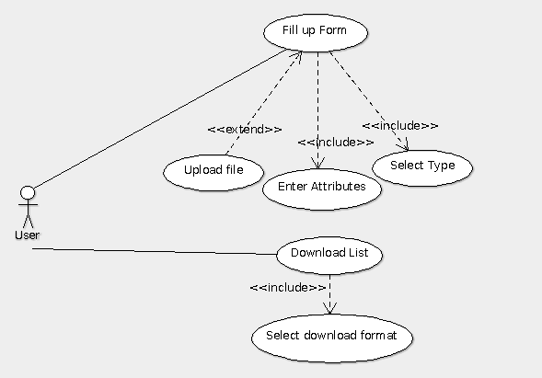

User performs following activities:

* Fill Up form: User selects the type of publication, fills up the generated fields and upload the published documents.
* Views the list and downloads the list: User selects the type of formatting to generate the list and type of file to download the formatted list.

**Use Cases Involving Database:**

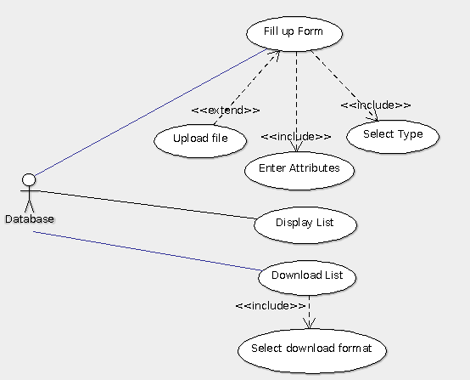

Database is associated in following activities:

* Form fill up process to store attributes, data and files.
* Generation of List: Database provides the data to generate the list of published materials.
* Downloading list: Database provides the data to download the list.